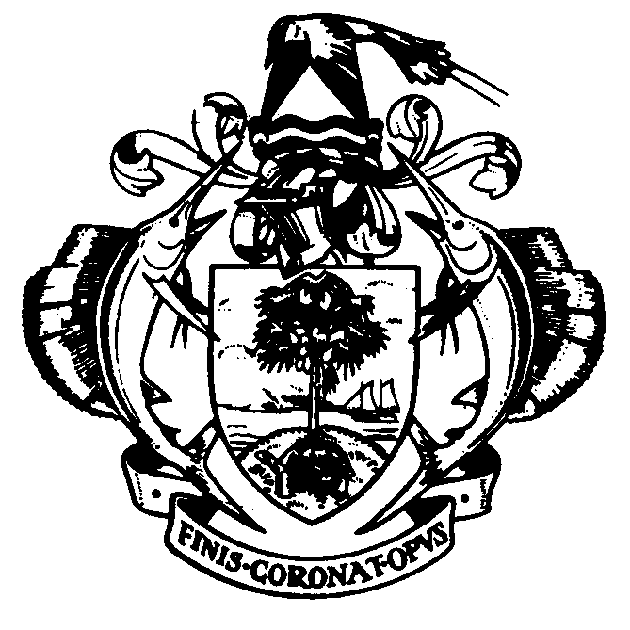
National Day Address
by
President James Alix Michel
18th June 2014
Dear People of Seychelles,
His Excellency Mr Jorge Carlos de Almeida Fonseca,
President of the Republic of Cabo Verde
Excellencies,
Distinguished guests,
The greatness of a country is determined by the greatness of its people. We are a small country on the global scale. But we are a people with great qualities. The great qualities that have enabled us to shape a unique nation. A nation that is proud and united in its diversity, its pluralism of opinions and beliefs. The great qualities that helped us to stand strong and overcome the most difficult, the most painful moments in our history. Exceptional qualities that have served us well in our endeavours to bring justice, progress and development in our country. Qualities that made the Seychelles star shine brightly. Qualities that distinguish us as a country. Qualities that make us, Seychellois, a great nation.
These are the qualities, our values as a people, that we celebrate when we commemorate our National Day. We celebrate them in solemnity, peace and unity.
It is always a great pleasure to share our joy, our values, our experiences, our accomplishments with the rest of the world. It is an even greater pleasure to share them with a brother who comes from a small island state like ours. This year, His Excellency Mr Jorge Carlos Fonseca, the President of the Republic of Cabo Verde, is our guest of honour for our National Day. We wish him a warm welcome to Seychelles and we sincerely thank him for sharing this great moment with us.
His Excellency Mr Jorge Carlos Almeida de Fonseca,
President of the Republic of Cabo Verde,
Dear Seychellois,
Excellencies,
Ladies and gentlemen
President Fonseca,
It is with immense joy that we welcome you in Seychelles. You are at home in Seychelles. In spite of the distance that separates us, our two countries have never been closer to each other, by virtue of our island heritage, our Creole heritage, our common ambition to promote the unity and solid partnership of island states and coastal countries of Africa, and our common desire for a fairer and a better world.
It is your first visit to Seychelles. We are so happy to have you among us on such an auspicious occasion, and we look forward to the fraternal exchanges we shall have. On behalf of all Seychellois, I wish you, and your delegation, our warmest welcome.
Dear People of Seychelles
The history of a nation, the history of a people, comprises different stages, certain decisive moments that characterise it and define its course. For us, one of these decisive moments is the 18th of June. The date is rooted in the collective memory of Seychellois. It opened a key chapter in Seychelles’ history. It commemorates the day the Third Republic was born. The day our nation adopted a new Supreme Law – our Constitution. The date also led to radical changes, changes in the political landscape, the strengthening of democracy, the transformation of the social and economic space, new ways of thinking, a wider projection of ourselves, and a wider outlook on the world – in short, a major step in the evolution of Seychelles.
Considering the circumstances of the time, the significance and historical aspect of the event, considering the wishes expressed by the great majority of the Seychellois, it was entirely appropriate for the founding fathers of the Third Republic to adopt the 18th of June as the National Day of Seychelles.
For twenty years we have celebrated the 18th of June as our National Day. We are celebrating it today also. But we are celebrating this date as our National Day for the last time.
We shall however continue to commemorate and honour this date which has marked our history. But we shall do it in a different way, while continuing to give it the recognition and importance it deserves.
Dear people of Seychelles,
As from next year, it will be the date on which we gained our Independence that will be celebrated as the new National Day. All the procedures for this change have already begun.
The rationale behind the declaration of 29th June as National Day is well-founded. First of all, it is for national unity. It is national unity which underpins our decision and which motivates each action we undertake for Seychelles. We need national unity in order to undertake the long march toward the New Frontier. We need to unite the whole nation for a common cause – Seychelles. We have to go forward in peace and harmony. If our origins and our diversity are not an obstacle for us to live together in peace, then why should our political affiliations divide us? Why do we allow our ideological differences to disrupt our harmony? The only solution – I am convinced – is national unity. For all Seychellois, the link between national unity and independence is inseparable.
Secondly, the adoption of Independence Day as the new National Day is dictated by historic reasons. On 29th June 1976 Seychelles became a sovereign, independent state.
This date symbolises the birth of a people, hope for the future, the achievement of victory, the crowning of a struggle. It also represents the unity of a people in a great manifestation of patriotic fervour. The 29th of June is an incontestable date in our history. It is a date that is unanimously accepted among Seychellois. It is a unifying date. A date that rallies us around the symbols that represent our wealth, happiness and well-being of the people that we are. It is about national unity, patriotism, solidarity, fraternity, love and respect for our fellow Seychellois.
It is quite right that we commemorate this indisputable date in our history with the importance that it deserves. That we accord it greater political, social, moral, institutional and cultural recognition. No one will ever contest this decision. It is the people themselves who have decided. We are doing it for all Seychellois. For our children. For posterity. For national unity.
People of Seychelles,
Seychelles is a dynamic country. We are moving rapidly, and facing new challenges. We have the capacity, courage, energy and resilience to overcome these challenges. We are doing it together, for the wellbeing, progress and prosperity of Seychelles.
Seychelles is today considered an upper middle income country. Can we transform Seychelles into a high income country in the next few years? Yes, we have the potential to do so. We have the potential to diversify and grow our economy. And this has been confirmed by the World Bank. A new study recently published has placed Seychelles among six middle-income countries with a high probability of transiting to a high-income economy in the years ahead.
This is a source of pride, satisfaction and motivation for us. But this transition will not happen by the waving of a magic wand. We need to organize ourselves! We must become more productive. We need to deepen our knowledge. Work harder. Become more creative and innovative. Attract more investment, local as well as foreign. Be smarter in the way we do business. Be smarter in our relations, and in the way we interact with the rest of the world. Be more responsible. Eliminate our weaknesses. Change our mindset.
We also need to harmonise our laws in line with our Constitution, modernise our legislation in conformity with best international practices, whilst taking into account our specificities, our culture and our traditions.
At same time we need to consolidate our gains. We must continue promoting an inclusive development, which touches all sectors of our society. We need to continue nurturing sustainable development, which includes our preoccupation with the protection of the environment, and which is aimed at a higher standard of living for the Seychellois people. An important aspect of our sustainable development policy is the judicious management and exploitation of our blue economy, as a major contributor to our wider economy in the future. Several projects to enable Seychellois to participate in the blue economy are in progress.
Our objective is a society of good values, based on mastery of knowledge. A society in which Seychellois assume key positions in all sectors. This is what will facilitate our transition to a high income economy. I am convinced that we will attain this objective.
As and when we attain this objective, we will have more resources at our disposal. This will allow us to invest more in the strengthening of social as well as physical infrastructures. Housing, in particular, remains one of our preoccupations. We must intensify our efforts to help families have access to their own homes. There are several measures we are going to announce in the near future to contribute toward this objective. This includes an increase in the Housing Loan Scheme, from SR500,000 to SR750,000; increase in Second Housing Loan, from SR300,000 to SR400,000; an increase in Housing Extension Scheme; and a review of the criteria for the Home Savings Scheme. The measures will become effective from 1st July. Alongside these measures, the Self-Financing Scheme will be activated between now and September with the starting of construction of houses at Ile Perseverance for people who have taken a loan under this Scheme.
A key element of our transformation into a high-income country is enhancing the entrepreneurial spirit and small business development. We need to have more small businesses, more medium enterprises, so that our economy continues to grow. They are one of the pillars of our economy and motors of our development. This is one of the sectors where public-private sector partnership can flourish, and we need to encourage it. My Government accords it great importance and we will continue to support its development and expansion. The opening of the Providence Microenterprise Centre in September will represent a significant step in this direction. Depending on demand and necessity, we will consider the creation of similar centres in regions in the future.
A country on the go needs all its dynamic forces. It needs all its youth. A youth full of energy, youth who are responsible, dynamic, and imbued with solid and patriotic values. Seychelles needs them. It is they, the youth of today, who will be our leaders tomorrow. We will continue to put resources at their disposal, to help them develop their potential and prepare them for the future. The future of the New Seychelles, which is being built with them.
Dear people of Seychelles,
During the 37 years that this party has been in power, our development policy has consistently focused on our people. Man has remained at the centre of development. This is the policy that has brought about social and political inclusion. That has eliminated discrimination. That has brought about justice, greater opportunities, greater well-being, and greater happiness for all Seychellois. This is what has brought about the progress of our country.
The progress of our country concerns all Seychellois. We all have a role to play in it, a contribution to make toward progress. But our leaders have a primordial responsibility in this respect. It is for this reason that they must remain connected with the people. Listen to them. Encourage them. Improve their living conditions. Manage their expectations where necessary.
In order for us to know what is really happening out there, we have to be out there. We have to remain engaged. We cannot remain enclosed in our offices, isolated in our small comfort zones, and just issuing directives. We have to respond to calls, be present, remain connected with the people. Let our actions set good examples. Make a difference in the life of a person, in the life of a community.
I make a formal appeal today, so that all Ministers, all National Assembly members, all District Administrators, continue to go to the districts, in the different communities, and discharge your duties. It is this way – by remaining connected with the people – that you will earn the respect, support and recognition of the people.
My appeal is also to all civil servants. Continue to take your responsibility seriously. Improve your work productivity and add value to it. Treat people with respect and serve them well. Treat all people equally. The laws and regulations must apply to all people equally, without distinction, without discrimination and without preference.
The government of a dynamic society attaches great importance to democratic values. This government respects and practices the rule of law. It is conscious of its duty, its responsibility, to guarantee all its citizens order, peace and security. It is conscious that democracy needs to evolve. It looks for all means, in consultation with the people, to strengthen the country’s democratic institutions. This is what defines my government. It is a government that remains alongside the people. A government that remains connected with its people.
I have made a lot of consultations and reflections. I have found it necessary, at the stage that we have reached, and in the interest of our nation, to set up a consultative forum that will contribute to our remaining connected with the people.
This high level forum, which I shall chair myself, will include certain individuals – irrespective of their political affiliations – who have distinguished themselves by their knowledge, their experience, their goodwill and service to the nation. The role of this forum will be to deliberate on all issues which directly impact the national interest, and to make concrete proposals which government will consider seriously. Its members will be entirely free to debate any issue that concerns the future of Seychelles in any domain – national unity, inclusivity, political, economic, social, moral, cultural, etc.
Consultations are the key to national unity. Consultations assist government in making good decisions. Through consultations democracy emerges victorious. It is this, and this alone, that motivates me to make this decision.
Dear Seychellois people,
Before I conclude, I ask you to join me in paying a deserved tribute to all the people and organizations that, during the past 20 years, have spared no effort in ensuring the success and brilliant performances of the National Day celebrations. I salute, particularly, our men and women in uniform. They ensure order, peace and security in our society, with a sense of duty and loyalty. They are the guarantors of our freedom. They are the defenders of our sovereignty and territorial integrity. We express our gratitude to them. We assure them that we will continue to take the measures that will improve their wellbeing.
I would also like to take this opportunity to express my gratitude to the French Armed Forces for their participation in our traditional parade. Thank you for your loyalty and for your support.
Dear people of Seychelles,
A people who are united are a people at peace with themselves. A people who are at peace with themselves are a great people. A great people, a generous people, who have banished hatred, intolerance, prejudice, conflict. Nothing is impossible when a people are united. Their ambitions for success are a measure of their aspirations. Their courage is unshakeable. Their determination is tenacious. Their vision is fixed on a better future. It is national unity that prevents and solves conflicts, and irons out our differences. Our biggest asset is our national unity. Nobody – I repeat nobody – will convince me of the contrary. Nobody will make me change my mind. Nothing is more important to me than this. And I will continue to dedicate my life, my energy, my work toward the promotion and strengthening of national unity. This is the only way to reach the new frontier. I know – and I am proud to say – that I can count on the great majority of Seychellois in this great enterprise. The New Seychelles depends on us. Let us do it together for the New Seychelles. For our children.
I thank you all, and I wish all Seychellois here and all over the world, a joyous National Day.
May God continue to guide and preserve our country.

